# Lab Manual 7

# Adders & Multiplexers

## Objectives

To learn and understand the working of adders and multiplexers

**ADDER:**

A half adder is a combinational circuit that adds two binary inputs. It gives two outputs, S as the sum and C as the carry of the inputs. A full adder is a combinational circuit that adds three binary inputs X, Y and Z. The input Z is the carry input from another addition. It gives two outputs, S as the sum and C as the carry of the inputs.

The circuit for the adder/subtractor shown in figure 5.3 is used to do binary additions and subtractions. If Cin=0, addition is performed and if Cin=1, subtraction is performed.

| **A** | **B** | **C** | **Sum** | **Carry** |
| --- | --- | --- | --- | --- |
| 0 | 0 | 0 |  |  |
| 0 | 0 | 1 |  |  |
| 0 | 1 | 0 |  |  |
| 0 | 1 | 1 |  |  |
| 1 | 0 | 0 |  |  |
| 1 | 0 | 1 |  |  |
| 1 | 1 | 0 |  |  |
| 1 | 1 | 1 |  |  |

**Task 1:** Fill in the following truth table of half adder and full adder and draw the circuit from them.

## 

| **A** | **B** | **Sum** | **Carry** |
| --- | --- | --- | --- |
| 0 | 0 |  |  |
| 0 | 1 |  |  |
| 1 | 0 |  |  |
| 1 | 1 |  |  |



Circuit diagram of 4-bit adder/subtractor:

## 

**TASK 2:** Implement a circuit for 4-bit binary adder on trainer the truth table for the adder circuit is given below.

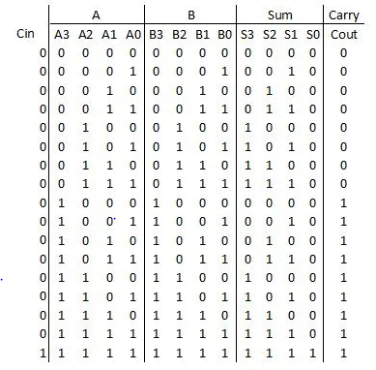

This is a 4-bit adder/subtractor circuit. The operation depends upon Cin. If Cin=0, addition is performed and if Cin=1, subtraction is performed.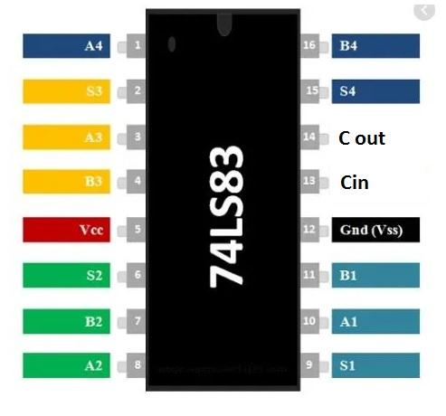

Pin Configuration of 74LS83:

**MULTIPLEXER:**

A MUX is a combinational circuit that can be used to select data and produce it at the output. They can be 2 to 1, 4 to 1, 8 to 1, 16 to 1, etc. It has a lot of applications. There are many scenarios in which we have to select a particular data and produce it at the output.

**2x1 MUX**

Following is the circuit for 2 to 1 MUX and truth table:

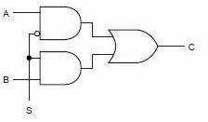

| **S** | **B** | **A** | **C** |
| --- | --- | --- | --- |
| 0 | X | 0 | 0 |
| 0 | X | 1 | 1 |
| 1 | 0 | X | 0 |
| 1 | 1 | X | 1 |

## 4x1 MUX

74LS153 IC is a dual 4x1 MUX with active low enables. Two 4x1 MUXs with common selection pins but independent inputs and independent outputs is known as dual 4x1 MUX. The function table and connection diagram for this IC are shown below:

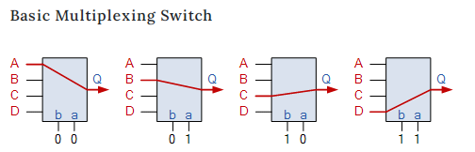

| **Strobe (Enable)** | **Selection Inputs** | | **Data Inputs** | | | | **Output** |
| --- | --- | --- | --- | --- | --- | --- | --- |
| **G** | **B** | **A** | **C0** | **C1** | **C2** | **C3** | **Y** |
| **H** | **X** | **X** | **X** | **X** | **X** | **X** | **L** |
| **L** | **L** | **L** | **L** | **X** | **X** | **X** | **L** |
| **L** | **L** | **L** | **H** | **X** | **X** | **X** | **H** |
| **L** | **L** | **H** | **X** | **L** | **X** | **X** | **L** |
| **L** | **L** | **H** | **X** | **H** | **X** | **X** | **H** |
| **L** | **H** | **L** | **X** | **X** | **L** | **X** | **L** |
| **L** | **H** | **L** | **X** | **X** | **H** | **X** | **H** |
| **L** | **H** | **H** | **X** | **X** | **X** | **L** | **L** |
| **L** | **H** | **H** | **X** | **X** | **X** | **H** | **H** |

**Connection Diagram 74LS153:**

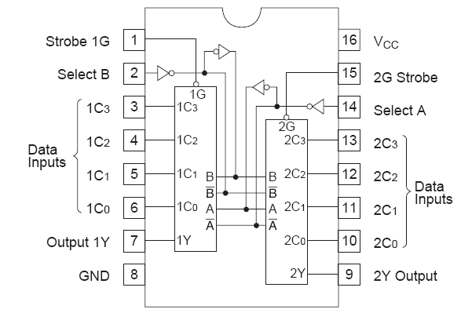

**Task 3:** Implement 4x1 multiplexer using the given IC on trainer.